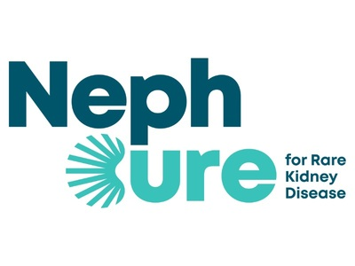
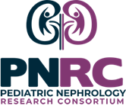

NephCure and The Pediatric Nephrology Research Consortium (PNRC) are very pleased to announce the NephCure-PNRC Pediatric Glomerular Disease Accelerator Grant Program and invite grant applications for both small and medium sized grants focused on Pediatric Glomerular Disease.
The “NephCure and PNRC Pediatric Glomerular Disease Accelerator Grant Program: Delivering Cures in a Decade” was born out of a desire to promote and support bench, translational, and clinical research focused on pediatric glomerular disease. This program is intended to stimulate novel collaborative research within the pediatric nephology community that will lead to measurable evidence-based improvements in the care of children with glomerular disease. This NephCure -PNRC collaborative effort will create the Pediatric Glomerular Accelerator Grant Program to fund research in the years 2022-2024.
Eligibility
- Grant applications must include investigators from at least two different institutions.
- Grant applications are open to Pediatric Nephrologists or Ph.D. Pediatric Nephrology Scientists with at least 50% appointments at medical or research institutions where the work will be performed.
- All applicant investigators will be expected to be Full Members of the PNRC prior to submission of the grant application.
Awards
- Proposed projects may be basic science, clinical or translational research in design.
- This program will fund multiple $10,000-$20,000 (Small Awards) and $50,000-$75,000 (Medium Awards) awards. Total grant awards will vary as funds and needs dictate.
- Grants will be awarded in two categories. Basic Science (2 grants awarded) and Clinical/Translational (2 grants awarded).
- Each award can support eligible research activities that include research supplies needed to accomplish the research project, investigator research effort, staff research effort, and travel to present research results at national and/or international professional meetings.
- Support for equipment will not be allowed.
- Indirect rates will be capped at 8% and must be included in the total budget allotted for each award level.

RFA release date: February 29, 2024
Deadline to accept applications: June 21, 2024(11:59 pm EST)
Please follow this link to apply:
https://pnrconsortium.org/nki-program/home

